Homepage

* Replace the image used for the impact section: I think you used a filter when you add the photo, I’m not sure what filter you used, but let’s try replacing with this image: <https://drive.google.com/file/d/1QQ4D7fQdNOAJfmGJqc7zTmhcySU60NJt/view?usp=sharing>

**Done**

* Interest Groups section: NSS requested to add “Group” to all the interest groups, so the current layout looks like this:  
  A group of animals in different groups

  Description automatically generated  
  You can see there’s misalignment due to the different lengths of each label. Is there anything we can do to align this? Ps I’ve shortened some of the text in the “Our Work” section, so that part appears aligned for me now 😊
* Footer: Events & Calendar is not linked.  
  **Done**

Singapore Bird Race

* Who can join? – The alignment is off for “Youth” as compared to the headers next to it (e.g. sprint, novice)

**Done**

* Who can join? – An icon is missing for the photographer

**Done**

Conservation

* Overview - Increase the spacing between "About NSS Conservation Committee" and the blurb above it

**Done**

ESN

* School programme components (Turn knowledge…) – by clicking on any option on the carousel (e.g. urban biodiversity monitoring), the image pops out with a short blurb. The header for the blurb has a “<br/>” that should be deleted

**Done**

Nature Watch

* Ensure image of all nature watch magazines are of the same size – somehow the left-most magazine is smaller than the other two next to it

Done, but I saw that the link for downloads are the same, please check.  
Instead of linking to image, place link it under the LINK container.   
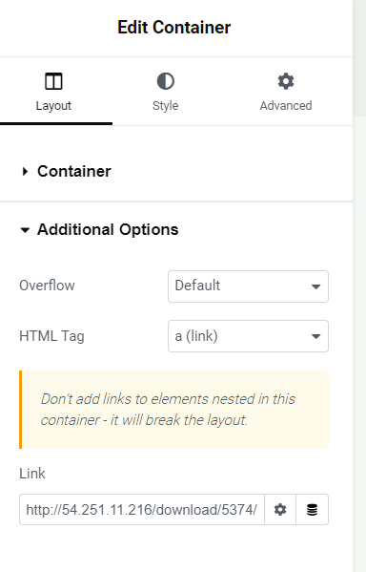

Let me know if you have any trouble.

All publications & reports

* Follow the 8 tabs format as shown in the Google Drive folders (<https://drive.google.com/drive/folders/13C7HkgVaAIb55spfy5wGBOH1zwSJjABG>)

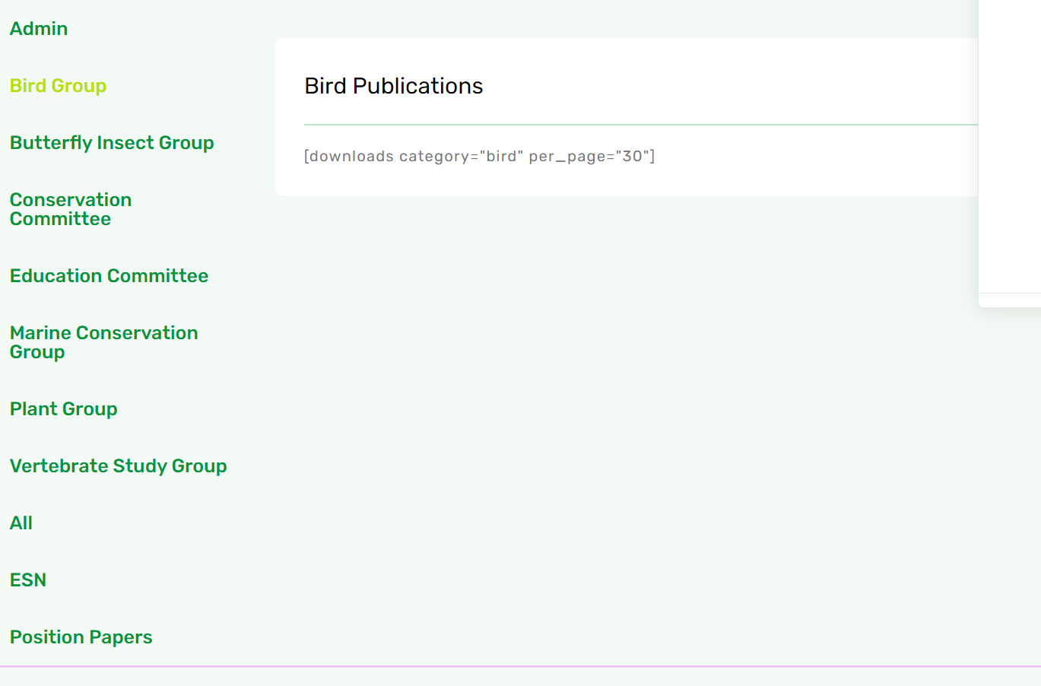

Is this what you meant? The tab used to be above, but the names are too long, so its better to organize on the side. The published paper also needs to be linked from the archive with the right category. Are we doing it or them will be organizing and upload themselves?

Newsroom

* Add more videos in NSS in the news
  + <https://www.facebook.com/naturesocietysingapore/videos/cna-news-on-the-international-horseshoe-crab-conference-hosted-by-nss/2272525933091129/>
  + <https://m.youtube.com/watch?v=caXYrPANnWE>
  + <https://m.youtube.com/watch?v=j8GUJFaFWp0> (10:40-13:06)
  + <https://m.youtube.com/watch?v=8tR3R7kTxZo> (10:47 - 14:05)
  + <https://m.youtube.com/watch?v=Zt894yqFkj0> (6:15 - 6:38)

Can only add like this, fixed format.

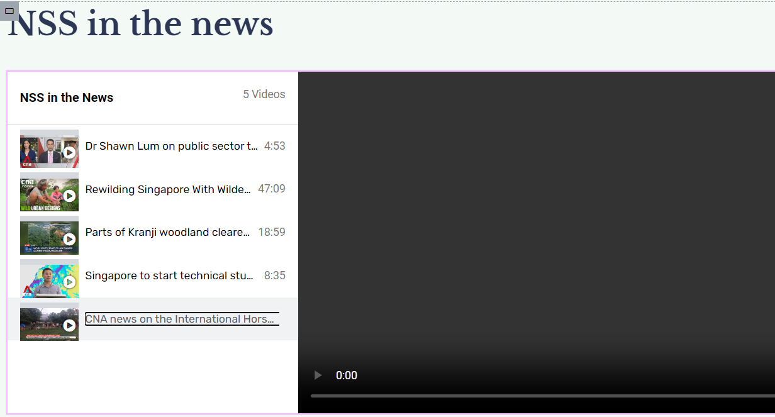

Note that only youtube can get video info, facebook link will not be able to get the thumbnail image from the video. Just in case you are wondering.